**CODE:**

void setup()

{

Serial.begin(9600);

pinMode(5,OUTPUT);

pinMode(2,INPUT);

}

void loop()

{

double data=analogRead(A2);

double n=data/1024;

double volt=n*5;

double off=volt-0.5;

double temp=off*100;

Serial.print("temperature value:");

Serial.println(temp);

int motion=digitalRead(2);

if(temp>=60)

{

tone(5,300);

delay(1000);

}

else if(motion==1)

{

tone(5,400);

delay(1000);

}

else

{

noTone(5);

delay(1000);

}

}

**SIMULATION:**

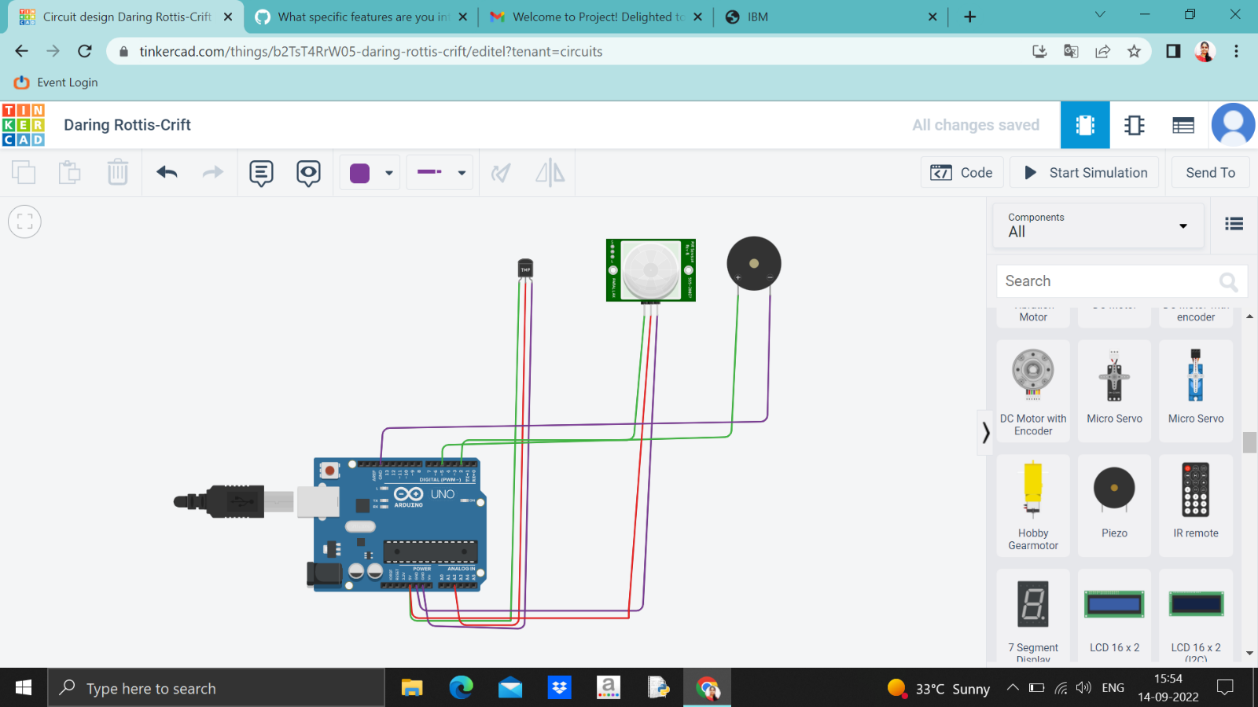

**OUTPUT:**

